Use Case Realisation Report (Analysis) - Assign Role to Project Member
FOR
Volunteer Management System
(VMS)

CLIENT
PROJECT | Volunteer Management System (VMS)
TITLE | Use Case Realisation Report (Analysis) - Assign Role to Project Member
VERSION | 0.1a
DATE | 13-Aug-2011
 | ORIGINATOR
 | Name / Signature | Team 8S
 | APPROVAL
 | Name / Signature | Phung Kim Cuong, Dio
Institute of Systems Science |  | Document Reference
25 Heng Mui Keng Terrace  Singapore 119615 |  | VMS/T-1.4.1/1

 | Acceptance
 | Customer Signature |  | Customer Signature
 | Name & Designation |  | Name & Designation
 | Date & Company Stamp |  | Date & Company Stamp

Revision History

Date | Version | Description | Author
12-Jun-2011 | 0.1a | Creation | Team 8S
 |  | Refer to amendment history

Table of Contents

1. Brief Description 3
2. Flow of Events 3
2.1 Assign Role to Project Member: 3
2.2 Exceptions 4
3. Interaction Diagrams 5
3.1 Collaboration Diagram for Assign Role to Project Member 5
4. Participating Objects 5
4.1 Staff 5
4.2 Project Manager 5
4.3 Project 5
4.4 Membership 5
4.5 ProjectMemberScreen 6
4.6 HomeScreen 6
4.7 MainController 6
4.8 MembershipController 6
4.9 StaffController 6
4.10 ProjectController 6
5. Class Diagrams 6
6. Derived Requirements 6
ANNEX D Amendment History 7

Use Case Realisation Report (Analysis) - Assign Role to Project Member

Brief Description
The use case enables a Project Manager to review the list of project members and to assign the roles to them. The role can be Team Lead or member.

Flow of Events
The standard flow of events for this use case and any exceptions are described in the following subsections. See section 3.1 for an overview of the participating Actors and Domain Objects.
Standard Flow
Precondition: User has logged in the system and the user role is project manager.
The workflow is as below:

Assign Role to Project Member:
- The use case starts when the Project Manager selects the menu option from the HomeScreen. The HomeScreen.assignProjectMember() operation is triggered.
- The HomeScreen.assignProjectMember() operation triggers the MainController getProjectMemberScreen() which delegates to the MembershipController’s getMembershipList() operation.
- Using the current logged in userID, the MembershipController will call the StaffController.getStaffDetails().
- Then the Staff.getStaff() operation will be triggered to return an instance of the current staff.
- With the instance of the staff, the ProjectController.getProjectList() will be triggered.
- Then the ProjectController will call Project.getProject() method to return the collect of the projects under this project manager.
- For each of the project, then the MembershipController will call the Membership.getMembership() to return the list of members for that project.
- With the list of project and its members, the MembershipController will call the ProjectMemberScreen.show() method to display the list.
- After that, the Project Manager will key in the role assignment and click Submit, this action will trigger the ProjectMemberScreen.enterMemberAssignment() method.
- The above method will be delegated to MembershipController. enterMemberAssignment() method, which in turn will call the update() method for each Membership entity.
- The MembershipController then display a message to user via sendMessage() method.
- The use case terminates when the Project Manager click Close button on the ProjectMemberScreen, which trigger its close() operation.

Exceptions
No exceptions was identified.

Interaction Diagrams

Collaboration Diagram for Assign Role to Project Member
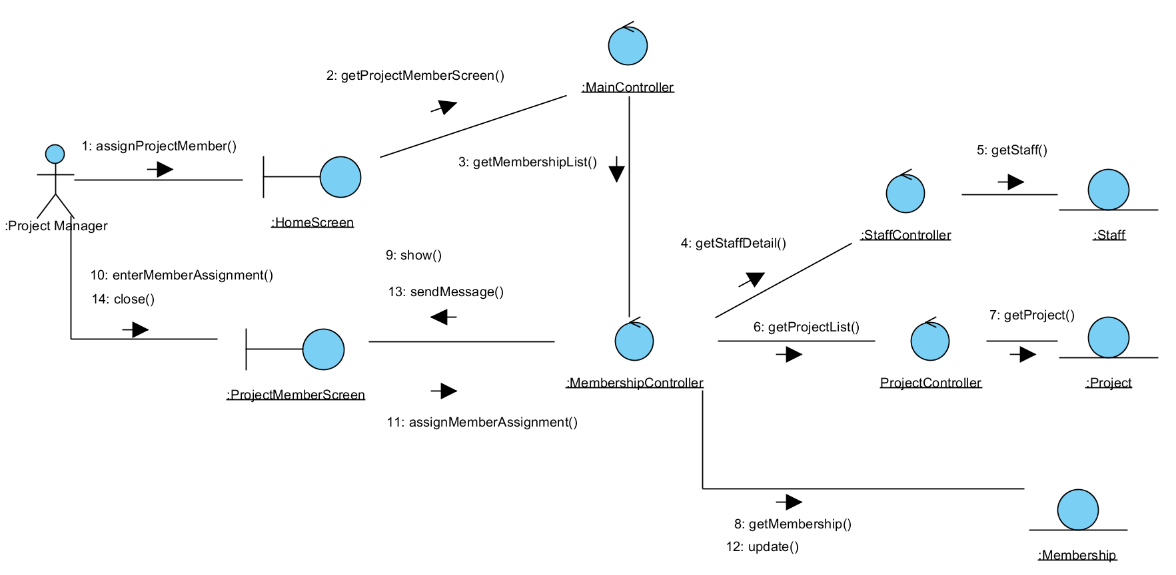
Figure 1 – Assign Role to Project Member

Participating Objects

Staff
This entity object stores the details concerning a staff of the volunteer organisation. The primary attribute that it holds is the userID.

Project Manager
This is a Staff object type with a project manager role as an attribute.

Project
This entity object stores the details concerning a project of the volunteer organisation. The primary attribute that it holds is the projectID.

Membership
This entity object stores the details of an assignment for each project member.

ProjectMemberScreen
This boundary object is used for collection of project member listing and for member role assignment. Project Manager interact with this object.

HomeScreen
This boundary object is used for redirecting and displaying of home screen details and menu. All the user actors use this object.

MainController
This control object co-ordinates the menu selection and dispatches of requests of the volunteer management system. It delegates the user requests to the specific use case control objects for carrying out the use cases.

MembershipController
This control object co-ordinates the creation, update, viewing and searching project membership in the system. It receives requests from the boundary objects allocated for the specific purposes, along with all the necessary details required for the execution of these requests.

StaffController
This control object co-ordinates the creation, update, viewing and searching of staff in the system. It receives requests from the boundary objects allocated for the specific purposes, along with all the necessary details required for the execution of these requests.

ProjectController
This control object co-ordinates the creation, update, viewing and searching of project in the system. It receives requests from the boundary objects allocated for the specific purposes, along with all the necessary details required for the execution of these requests.

Class Diagram

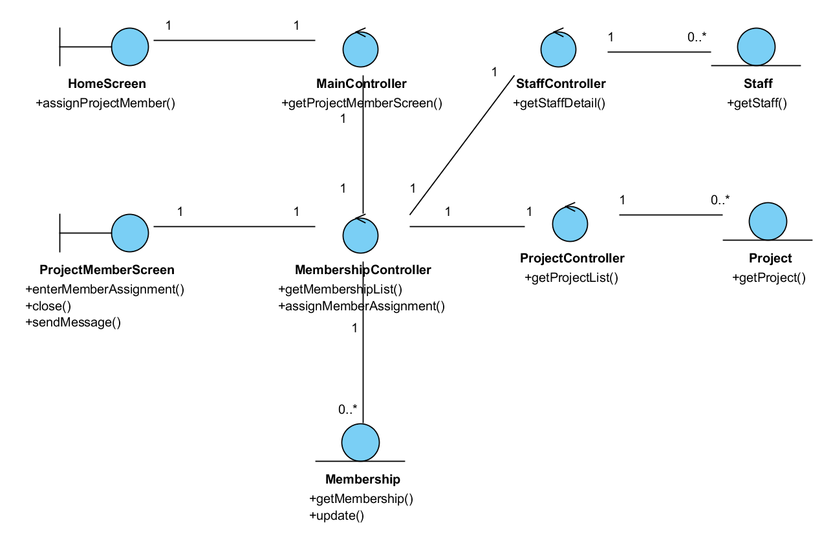
Figure 2 Class Diagram

Derived Requirements
The Staff office PC (client system), keyboard and mouse will be used to process the project details and view all the system responses.

ANNEX D Amendment History

This is a record of all amendments made to the Document.
Version | Chapter / Section | Page No | Notes of Amendments or Changes

